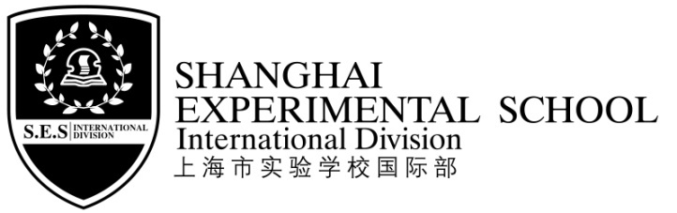
通 知Notice
各位同学及家长Dear Parents and Students，
本学期期末安排如下，请根据要求调整好自己的学习生活。
The arrangement of the final session is as follows. Please adjust your studies according to the schedule.
时间Time |  | 内容Content | 备注Remarks
6月13日  周三上午  13th .Jun  Wednesday morning |  | 数学、英语期末考试  Maths and English Examination | 两天早晨均按原时间到校，校车原时间接。  学生均不在校用餐。  6/13、6/14两天放学时，乘坐校车的同学均在学生餐厅候车，两天校车均11：00送，放学时间均为11：10。  另：6/14日四、五年级学生考试后将作毕业典礼准备，在校吃午餐，13：30结束，无校车，请家长安排好孩子的接送，谢谢！  Students arrive at school as usual, and the school bus will pick them up. Students will not have lunch at school.  On Jun.13th and Jun.14th, school is dismissed right after the test and students who take school bus home will wait at the school dining room after the test and the bus will leave school at 11:00.The rest of the students will leave at 11:10.  Addition：Grade 4 & 5 students will prepare for school graduation ceremony after the exam on June 14 th, and they will have lunch at school. They can go home at 13:30. No school bus that day. Please do the arrangement beforehand.
6月14日  周四上午  14th .Jun  Thursday morning |  | 语文期末考试、故事妈妈活动  Chinese Examination  and Story Mommy activity
6月15日  15th .Jun |  | 毕业班毕业典礼  （四年级学生、五年级学生及家长参加）  Graduation ceremony  (participants: the fourth graders  and fifth graders with their parents) | 时间：10：00——11：00。  地点：阶梯教室  Time period: 10:00---11:00  place: lecture theatre  （其他年级学生不用到校）  （Other graders don’t need to go to school）
6月16，17日  16th .Jun，17th .Jun |  | 双休日休息  Rest | 学生不用到校  No need to come to school
6月18，19日  18th .Jun，19th .Jun |  | 休息  Rest | 学生不用到校  No need to come to school.
6月20日  周三  20th Jun  Wednesday | 上午  AM | 期末试卷分析  &学生结业式  Discussion on final examination & Closing Ceremony | 早晨按原时间到校，校车原时间接。  不在校用餐，校车11：20送，11:30放学。  Students won’t have lunch at school. They will arrive at school as usual, and the bus will leave school at 11:20. The rest of the students will leave at 11:30.
6月20日  周三  20th Jun  Wednesday | 下午  PM | 接待家长  汇报学生学期表现  Parents Meeting: students’ performances of the semester | 接待时间Time：13:00－15:00  接待地点Place：各班教室Respective classrooms.
6月21—30日  From Jun.21st to Jun.30th |  | 休息  Rest | 学生不用到校  No need to come to school.

附：各年级各学科考试时间
项目  年级 | 6月13日  周三June. 13th |  | 6月14日  周四June. 14th
项目  年级 | 数学  Maths | 英语  English | 语文  Chinese | 故事妈妈  Story Mommy
一年级Grade One | 8:30~9:30 | 9:45~10:25 | 8:30~9:30 | 10:10~10:45
二年级Grade Two | 8:30~9:30 | 9:45~10:25 | 8:30~9:40 | 10:10~10:45
三年级Grade Three | 8:30~9:30 | 9:45~10:25 | 8:30~9:50 | 10:10~10:45
四年级Grade Four | 8:30~9:30 | 9:45~10:45 | 8:30~9:50 | 10:10~10:45
五年级Grade Five | 8:30~9:30 | 9:45~10:45 | 8:30~10:00 | 10:10~10:45

希望家长鼓励孩子认真复习，也请家长提醒孩子准时参加学校期末各项教育教学活动。
We hope parents could encourage your children to have a good revision, challenge themselves and try to do their best and also remind your children to be on time for all teaching activities as outlined in the schedule above.

7月1日——8月31日暑假，9月1日——2日双休日，9月3日（周一）开学，暑假具体要求及开学期间安排另发通知。
Summer vacation is from 1st July to 31 ^{st} August. Sep. 1st and 2nd are weekends, so the new term will begin on 3 rd Sep. Detailed summer vacation requirements and the arrangement of the beginning of next new semester will be given in another notice.

致礼
Thanks！
上海市实验学校国际部
SES International Division
Jun.2012

