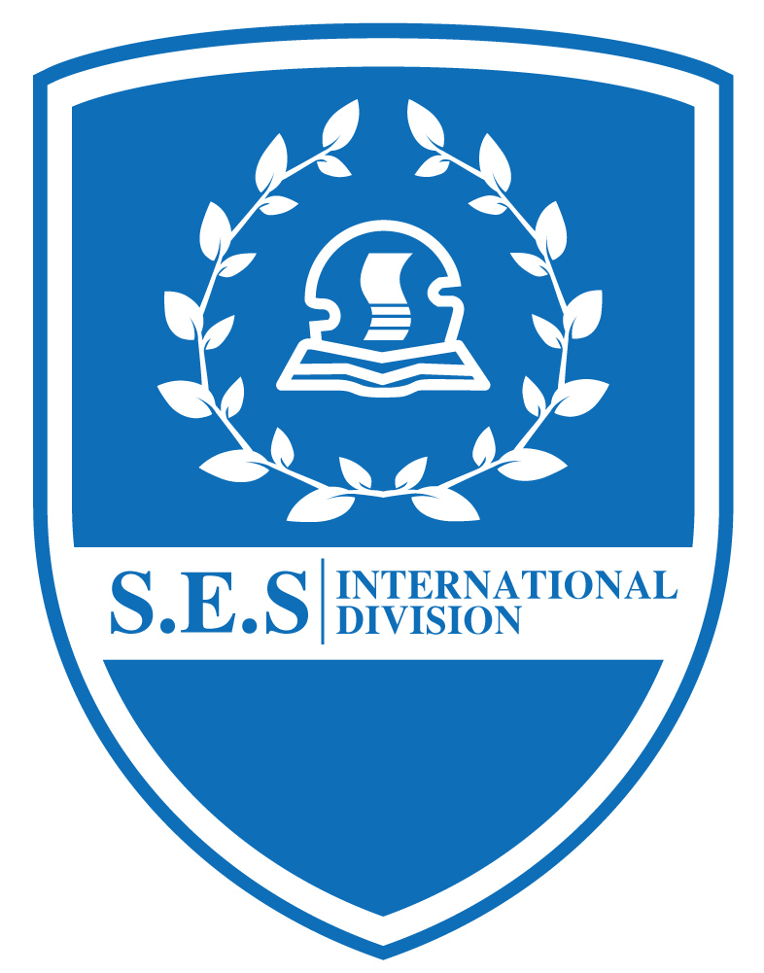
Kids Menu
( Dec 17— Dec 21,2018 )
Date | Day | Menu
Dec. 17 | Monday | 蚝油牛肉、港式蒸饺、三鲜鱼面筋、榨菜肉丝蛋汤  Fried beef in oyster sauce, Steamed Dumpling, Fish Gluten, Shredded Egg Soup with Preserved Vegetable Meat
Dec. 18 | Tuesday | 葱油鸡腿、洋葱肉丝炒饭、西葫芦肉片、炒素、番茄土豆汤  Chicken leg with onion oil, fried rice with onion shredded meat, sliced zucchini meat, fried vegetable, tomato potato soup
Dec. 19 | Wednesday | 红烩牛肉、酱爆肉丁、青椒银芽肉丝、油豆腐虾皮粉丝汤  Red stewed beef, sauce and fried pork dice, green pepper and shredded meat, fried bean curd and shrimp skin vermicelli soup
Dec. 20 | Thursday | 烤鸡翅、黑椒牛肉丝意面、黄金地瓜条、奶油西兰花、罗宋汤  Roasted chicken wings, black pepper beef pasta, sweet potato strips, buttered broccoli, borscht soup
Dec. 21 | Friday | 红烧大肉圆、香烤大虾、日本豆腐烩培根、咸肉萝卜汤  Braised meatballs, roasted prawns, Japanese tofu stewed bacon, bacon and carrot soup

