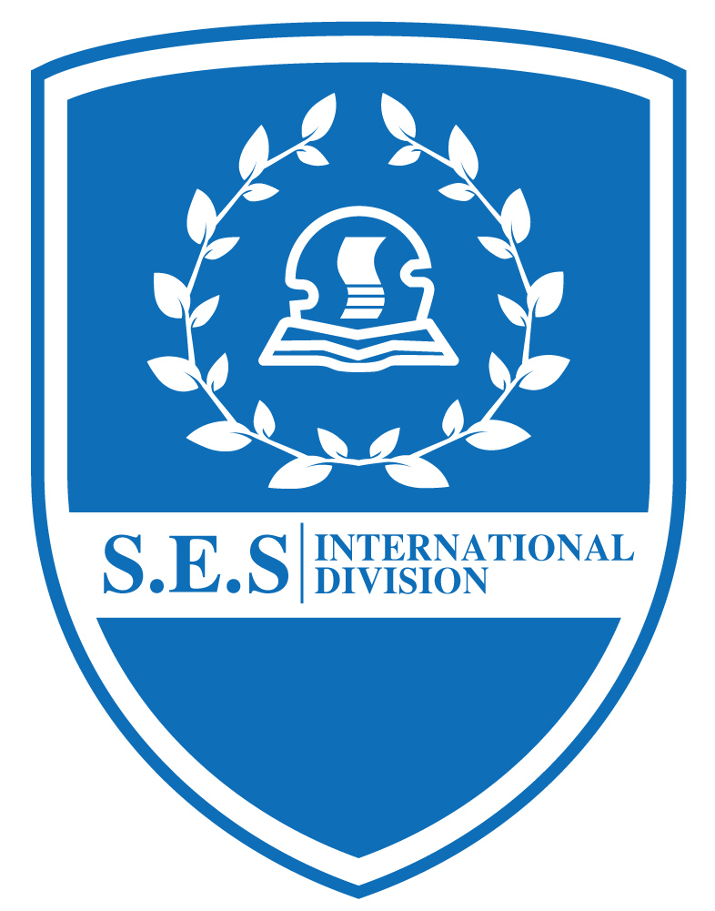
Kids Menu
( Dec 26— Dec 29,2018 )
Date | Day | Menu
Dec. 26 | Wednesday | 洋葱牛肉丝、腊肉菜饭、咖喱土豆鸡丁、青椒银芽鸡丝、咸肉萝卜汤  Shredded beef onion, bacon, rice, curry potatoes, diced chicken, green pepper, bacon and radish soup
Dec. 27 | Thursday | 烤鸡翅、奶油蘑菇培根意面、薯条、白灼西兰花、罗宋汤  Roasted chicken wings, buttered mushroom bacon pasta, French fries, braised broccoli, borscht soup
Dec. 28 | Friday | 红烧大排、香橙烤鸭片、白菜肉丝、香菇青菜、油豆腐粉丝虾皮汤  Roast steak with red sauce, roast duck slices with orange, shredded cabbage, mushroom and green vegetables, shrimp skin soup with fried bean curd and vermicelli
Dec.29 | Saturday | 虾仁炒蛋、蚝油牛肉、芹菜香干肉丝、番茄土豆汤  Shrimp scrambled eggs, oyster sauce beef, dried celery shredded meat, tomato potato soup

