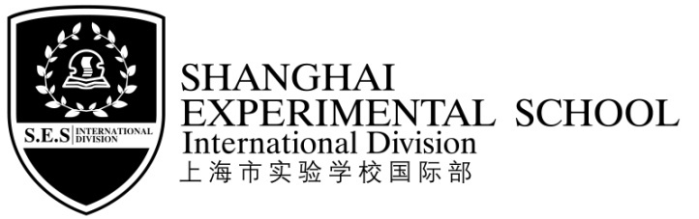
通 知Notice
各位同学及家长：
Dear Parents and Students,

2018学年第一学期期末安排如下，请根据本安排调整好自己的学习生活。
The arrangement of the final period of this semester is as follows. Please adjust your schedule according to the table.

时间Time |  | 内容Content | 备注Remarks
1月14日  周一上午  Jan. 14th  Monday morning |  | 语文期末考试  Chinese Examination | 1、三天早晨均按原时间到校，校车原时间接。  2、学生三天均不在校用餐。  3、三天考试结束，校车均10:10送，不乘校车的学生三天均10:20放学。  4、1/16请同学们每人自备大储物袋，考试结束后将台板和书包柜清空，所有物品带回家。  5、1/16四~五年级学生考试结束需参加“加拿大国际艺术大奖赛”启动仪式，不在校午餐，学校会为学生准备点心，活动结束后无校车，请家长11:40来校接孩子。  - Students will arrive at school as usual, and the school bus will pick them up.  - Students will not have lunch at school.  - The school bus will leave at 10:10.The rest of the students will leave at 10:20.  - Please bring a bag to put your belongings and take them back home on Jan.16th.  5. On Jan.16th, G4 and G5 students need to participate in the opening ceremony of Canadian International Art Show. They won’t have lunch at school but snacks will be prepared. Please pick up your kid at 11:40. There will be no school buses.
1月15日  周二上午  Jan. 15th  Tuesday morning |  | 数学期末考试  Maths Examination
1月16日  周三上午  Jan. 16th  Wednesday morning |  | 英语期末考试  English Examination
1月17—22日  From Jan.17th to Jan.22nd |  | 休息  Rest | 学生不用到校  No need to come to school
1月23日  周三  Jan.23th  Wednesday | 上午  AM | 学生期末试卷分析、结业式  Class discussion on final examination results | 期末试卷分析和结业式是重要教育教学活动，应该准时参加，不缺席。  1、早晨按原时间到校，校车原时间接。  2、不在校用餐，校车11：20送，11：30放学。  The feedback on final examination papers and closing ceremony are important education activity in SES. Please be on time. Don’t miss it!  - Students will arrive at school as usual, and the school bus will pick them up.  - Students will not have lunch at school.  The school bus will leave at 11:20. The rest of the students will leave at 11:30.
 | 下午  PM | 接待家长  汇报学生学期表现  Parents Meeting | 接待时间Time：13:00－15:00  接待地点Place：各班教室Your child’s classroom.
附：各年级各学科考试时间
项目  年级 | 1月14日  周一 Mon. Jan. 14th | 1月15日  周二Tue. Jan.15th | 1月16日  周三Wed.Jan.16th
 | 语文Chinese | 数学Maths | 英语English
一年级Grade One | 8:30~9:30 | 8:30~9:30 | 8:30~9:10
二年级Grade Two | 8:30~9:40 | 8:30~9:30 | 8:30~9:10
三年级Grade Three | 8:30~9:50 | 8:30~9:40 | 8:30~9:20
四年级Grade Four | 8:30~9:50 | 8:30~9:40 | 8:30~9:30
五年级Grade Five | 8:30~9:50 | 8:30~9:50

希望家长鼓励孩子认真复习，也请家长提醒孩子准时参加学校期末各项教育教学活动。
We hope that you could encourage your children to revise before the finals, and also remind your children to be on time for all the activities in the schedule above.
1月24日——2月19日寒假，2月19日（周二）全校学生注册报到，2月20日（周三）正式开学，寒假具体要求及时间安排另发通知。
Winter vacation is from Jan.24th to Feb.19th. Students should come to school for registration on Feb.19th (Tuesday) and the new term will begin on Feb.20th(Wednesday). Further detailed information about winter vacation will be given in another notice.
致礼
Thanks！
上海市实验学校国际部
SES International Division
Jan.2019

